**AN INDUSTRIAL TRAINING REPORT ON**

**CONSTRUCTION OF PWD**

**TAKEN AT**

**PUBLIC WORK DEPARTMENT (PWD) GHUMARWIN**

SUBMITTED IN PRACTICAL FULFILMENT OF THE REQUIRMENT FOR THE AWARD OF THE

DIPLOMA--

**IN**

**CIVIL ENGINEERING**

**Parth Sharma**

**FROM 10/01/2024 TO 06/02/2024**

**DEPARTMENT OF CIVIL ENGINEERING**

**Govt Polytechnic Kinnaur Campus at Govt Polytechnic Rohru distt Shimla**

**HIMANCHAL PRADESH**

**AFFILITATED TO**

**HIMANCHAL PRADESH TAKNIKI SHIKSHA BORD ,DHARMSHALA(HP)**

|  |  |  |
| --- | --- | --- |
| **S.NO** | **TITTLE** | **PAGE NO** |
| 1 | PROJECT DETAIL |  |
| 2 | SITE VISIT |  |
| 3 | COMPONENTS OF BUILDING |  |
| 4 | PLINGTH SLAB |  |
| 5 | GRAPH SHEET PLAN |  |
| 6 | MATERIAL TESTING |  |
| 7 | BRICK MASANORY |  |

|  |  |  |
| --- | --- | --- |
| 8 | FORM WORK |  |
| 9 | SHUTTRING |  |
| 10 | BEAMS AND COLUMBS |  |
| 11 | CONCRETE MIXTURE |  |
| 12 | CONCLUSION |  |

**ACKNOWLEDGEMENT**

I take this opportunity to extent my graduated to PUBLIC WORK DEPARTMENT GHUMARWIN having provided me with unbelievable practicle training learning experience during Industrial training It was indeed a pleasure to be a part of such organization

First and for most , I would like to thank MR PUNEET SHARMA ,for providing me with the opportunity to work under their guidance and close supervision Secondly I am also great full to other employess and member of the department for their kind Co-operation and spontaneous respons

Last but not the least I experience my graduated toward Mr Puneet Sharma HEAD OF DEPARTMENT

to give me chance to work with this prestigious organization

SUMITTED BY :-

Parth Sharma

**Govt Polytechnic Kinnaur at Govt Polytechnic Rohru**

**ABSTRACT**

Industrial training offerd byPublic work Department It was fortunate opportunity for me during my 1 month industrial training

It helped me a lot to apply my practile knowledge gaind during the academic program me into real world industrial based execution and experience perfessional construction process it helped me enhance my skill and to enchir my industrial based knowledgement by keeping me update with lastest technologies this opportunity is extremely helped me to expose into and environment where I could think as a civil engineer

I had my training experience from 10 /Jan/2024 to 06/Feb/ 2024 At PWD Ghumarwin This Report Documents contain .The knowledge And experience I have gained through my Industrial training at PWD Ghumarwin distt Bilapsur (174021)

------

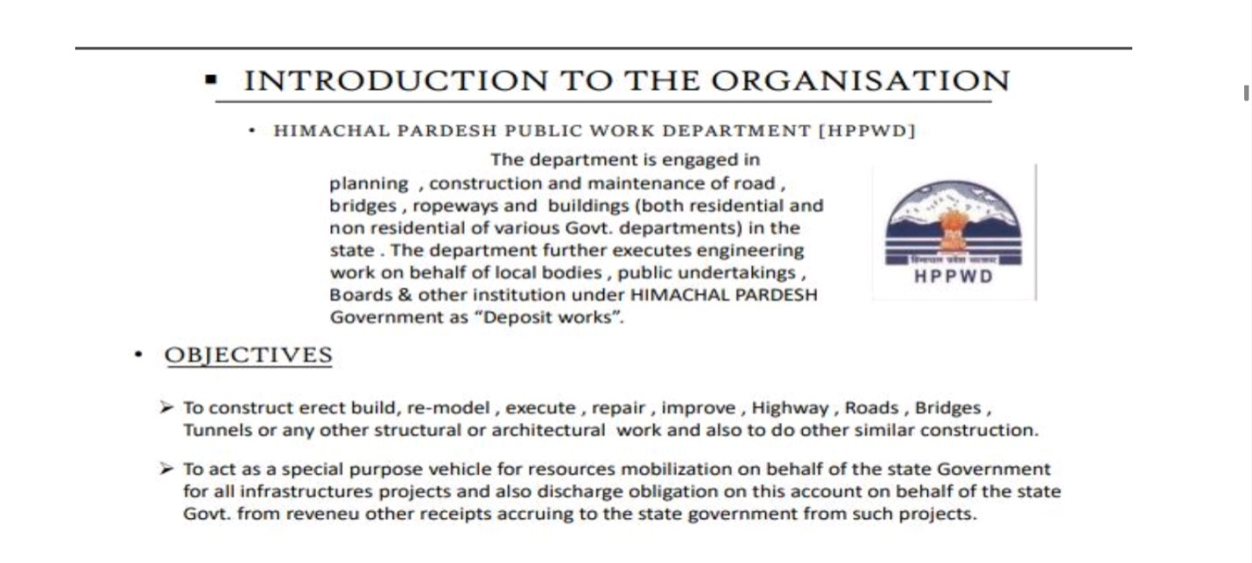

**PROJECT DETAIL**

**CONSTRUCTION OF MINI SECRETARIAT AT GHUMARWIN DISTT BILASPUR (H.P.)174021**

1 CLIENT :- PUBLIC WORK DEPARTMENT , GHUMARWIN

2 ESTIMATED CODE :-

3 STARTING DATE :-

4 SITE LOCATION :- NEAR DAKRI CHOWK OPPOSITE TO PWD OFFICE , GHUMARWIN DISTT BILASPUR (H.P.)174021

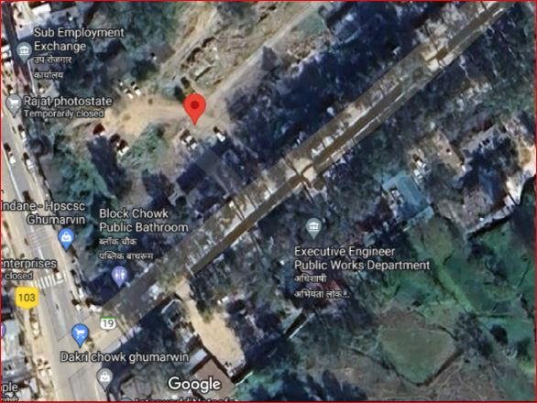

**PLAN SHOWING FOOTING**

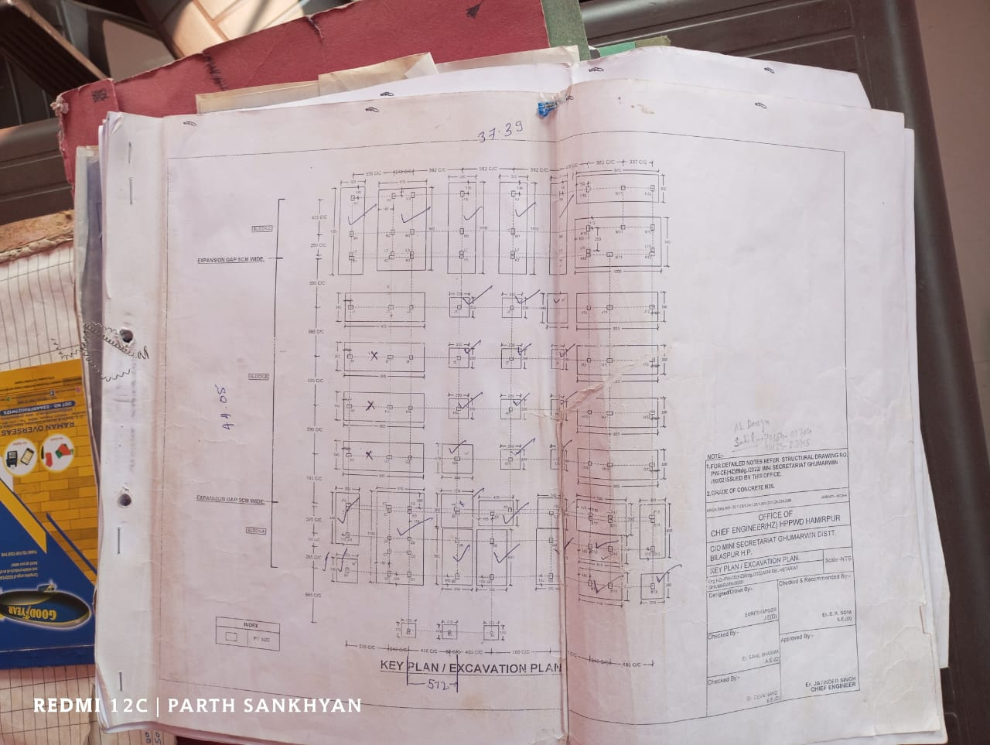

**SITE VISIT**

Construction site visit are interactive experience that that enhance the student understanding of real construction practice . It creates an interactive learning environment for students . This Help strengthen classroom materials and classroom lesion to life

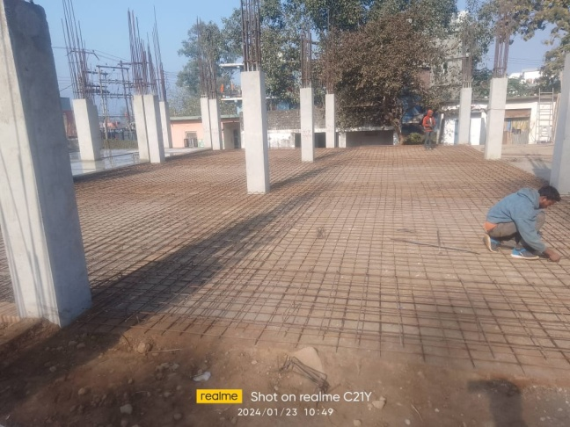 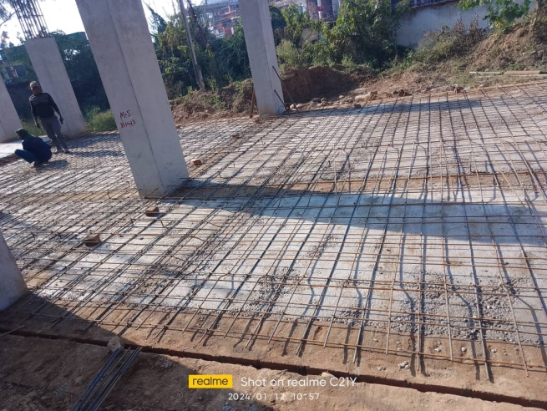

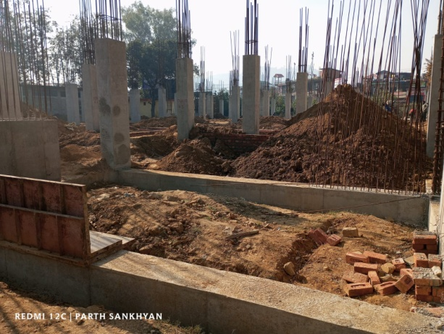

**COMPONENTS OF BUILDING**

* Sub structure
* Super structure

**3.1 SUB STRUCTURE**

Foundation is a part of sub structure. Sub structure is consider according to soil quality at that site . If soil quality at that site . If soil have good bearing capacity then we use shallow foundation in construction . And if the bearing capacity of the soil is not good or suitable than we use deep foundation at that site . Sub structure is is load bearing structure is a load bearing

**FOUNDATION**

Foundation is lower part of the building or the civil structure which transmits the load of the structure to the soil lying undermeath

**FOUNDATION IS DIVIDED INTO TWO CSTEGORIES**

**A SHALLOW FOUNDATION**

* Isolated footing
* Comined footing
* Strip foundation
* Raft or mat foundation

**DEEP FOUNDATION**

* Pile foundation
* Drilled shafts foundation

**SUPER STRUCTURE**

Super structure is a part of structure that is above plingth level (P.L.) Generally columns and walls are consider as super structure

FOLLOWING ARE IMPORTANT PARTS OF SUPER-STRUCTURE

1 Floor

2Roof

3 Lintel

4Parapet

5Door

6Windows

7Rooms

**1. FLOOR: -** Floor is that part of a building on which furniture, household, commercial, industrial or any other type of items are stored. Floor is used for walking around.

**2. ROOF: -** Roof is made to cover room from upper face. Different types of roofs are used in building depending on the location and weather. Sloping roofs are generally considered better in mountain areas. While, in plan areas flat roofs are preferred.

**3. LINTEL: -** Lintel is constructed above doors, windows etc. to support load of wall on openings. Lintel beam is generally made as reinforced cement concrete member. While, in residential houses sometime lintel is made by using concrete and bricks.

**4. PARAPET: -** A parapet is typically the uppermost reaches of a wall that extends above the roof level and provides a degree of protection to roof, gutters, balconies and walkways of houses, churches, castles, and apartment blocks, commercial and other buildings

**5. DOORS: -** A door is a moving structure used to block off, and allow access to, an entrance to or within an enclosed space, such as a building or vehicle.

**6. WINDOWS: -** A window is an opening in a wall, door, roof or vehicle that allows the passage of light and, if not closed or sealed, air and sound.

**7. ROOM**: a portion of space within a building or other structure, separated by walls or partitions from other parts: a dining room. rooms, lodgings or quarters, as in a house or building.

**CEMENT:**

Cement was first discovered by an English brick layer named Joseph Aspdi n in 1824. He called it Portland cement for the reason that the cement he discovered resembled the limestone found in Portland. There are many other types of cement. The approximate composition of Portland cement is given below

|  |  |
| --- | --- |
| **Material** | **Composition** |
| 1.Lime (Cao) | 60-70% |
| 2. Silica (Si02) | 20-25% |
| 3. Ferric Oxide (Fe203) | 2-3% |
| 4. Alum ina (Al203) | 5-10% |

**Table - Composition of Portland cement**

The function of cement is lo combine with water and to from cement paste. This paste first sets i.e. it becomes firms and then hardens due to chemical reaction, called hydration, between the cement and water. On setting &hardening, the cement binds the aggregate together into a stone like hard mass &thus provides strength, durability &water-tighten to the concrete. Quality of cement is based on grade of cement. There are different types of Grade which use in construction work. These are given below.

• 33 Grade OPC is used for general construction works like plastering and finishing works in normal environmental conditions. However, its use is virtually phased out today.

• Coming to the 43 Grade OPC, it is the most commonly used grade for home foundations, brick work, and compound wall and so on. It has more strength

development than the 33 Grade cement.

53 Grade OPC develops strength very fast. High rise building constructions use 53grade cement.

This is applicable for use in structures where high -Grade concrete is required.

We used Portland cement of 43 grades (ACC CEMENT) at the constitutions site.

The cost of cement per beg = 350 rupees

The initial setting time of cement = 30 minutes. The final setting time of cement = 10 hrs.

**Aggregate**

Aggregate are small pieces of broken stones in irregular size and shapes. Neat cement is very rarely used in construction works since it is liable to shrink too much and become cracks on setting. Moreover, it will be costly lo use neat cement in construction work.

Therefore cement is mixed with some inert strong &durable hard materials.

They also reduce the cost of concrete because they are comparative much cheaper as cement. There are two types of aggregates

1. Fine Aggregate
2. Coarse Aggregate

**FINE AGGREGATE (SAND):**

The aggregate, which pass through 4.75 mm, I.S. sieve and entirely retain on 75 micron (0.075mm) I.S. sieve is known as fine aggregate.

**FUNCTION OF FINE AGGREGATE:**

The function of using fine aggregate in a concrete mix is to fill up the voids existing in the coarse aggregate and to obtain a dense and strong concrete with less quantity of cement and increase the workability of the concrete mix.

**COARSE AGGREGATE:**

The aggregate, which pass through 75mm, IS. Sieve and entirely retain on 4.75 IS. Sieve is known as coarse aggregates.

**FUNCTION OF COARSE AGGREGATE:**

The coarse aggregates are used in mixing of concrete. It is mixed cement, sand with water. These aggregates increase the strength of bonding in aggregates. Coarse aggregates are used in construction of plan cement concrete (PCC), foundation, beams and columns etc.

**PLINGTH SLAB**

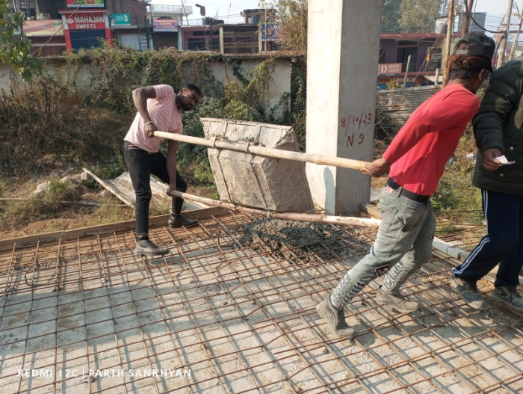 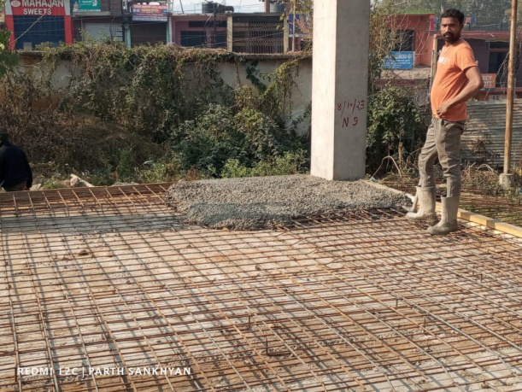

Plingth slab may be defined as the rectangular slab or block that forms the lowest part of the base of a column, statue, pedestal, or pier. 2. Also called: plinth course. the lowest part of the wall of a building that appears above ground level, esp one that is formed of a course of stone or brick

Plinth should be at least 1 ft. above the ground level; • Provide a reinforced concrete band at plinth level, as shown in figure; • Minimum thickness of plinth band should be 3 to 4 inch and width should be equal to wall thickness

In the above picture we can see labour people are putting plingth slab

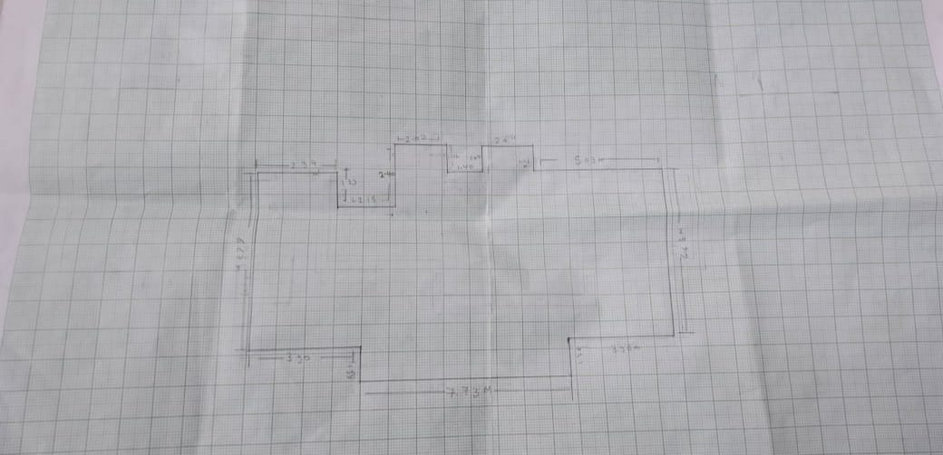

**LINE PLAN OF RESIDENTIAL BUILDING ON GRAPH SHEET**

**MATERIAL TESTING**

**TESTS OF AGGREGATES:**

Below are some of the important test which are perform on aggregates at every construction site to check the quality of the aggregate for better construction and fulfill the requirement of the client.

1. Crushing Test
2. Impact Test
3. LOS Angles Abrasion Test
4. Shape Test
5. Water Absorption Test.

**TESTS OF CONCRETE:**

Below are some of the concrete test which are perform on concrete at si te and laboratory.

1. Compressive Strength Test.
2. Permeability Test.
3. Slump Test.
4. Flexural Strength Test

**EQUIPMENTS USED FOR CONSTRUCTION**

After telling us about the material and their ratio used in construction work we get information about the equipment used their uses. Detail about the equipment mostly used in construction work is given following.

**BATCHING MACHINE:**

The measurement of materials for making concrete is known as batching. The machines which used for batching is known as batching machine.

**CONCRETE MIXER:**

This is a power mechanically operated machine which is used to mix the concrete. It consists a hollow cylindrical part with inner side wings. In which cement, sand, aggregates and water is mix properly.

**BIRCK MASONRY**

**MORTAR:-**

It's a plastic building material (such as a mixture of cement, lime, or gypsum plaster

with sand and water) that hardens and is used in masonry or plastering.

**Types of Mortar as binding material:**

Mortars are classified into the following five categories:

1. Cement Mortar

2. Lime Mortar

3. Surkhi Mortar

4. Gauged Mortar

5. Mud Mortar

At work site cement mortar is used and I :6 ratios are used to prepare cement mortar.

**CLASSOFBRICKS:**-

On the basis of quality and performance of brick is classified in th ree parts-

CLASS A

CLASS B

CLASS C

Class B bricks were used at site for wall masonry work.

Types of bond in brick masonry: -

There are four types bond which are used in wall masonry work

1. Stretcher bond

2 Header bond

3 English bonds

4 Flemish bonds

**1. Stretcher bond**

Longer narrow face of the brick is called as stretcher as shown in the elevation of figure below.

Stretcher bond, also called as running bond, is created when bricks are laid with only their stretchers

showing, overlapping midway with the courses of bricks below and above.

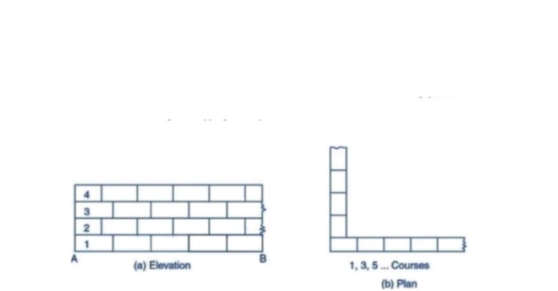

**2. Flemish Bond**

Flemish bond, also known as Dutch bond, is created by laying alternate headers and stretchers in a single course. The next course of brick is laid such that header lies in the middle of the stretcher in the course below, i.e. the alternate headers of each course are centered on the stretcher of course below. Every alternate course of Flemish bond starts with header at the comer.

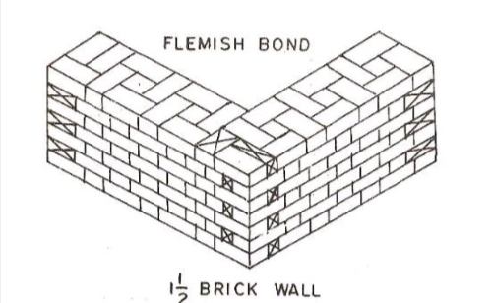

**FORMWORK**

Formwork is temporary or permanent moulds into which concrete or similar materials are poured. In the context of concrete construction, the false work supports the shuttering moulds.

Requirements of Good Formwork:

1. It should be carefully designed, so as to be strong enough to resist the pressure of fresh concrete and the super-imposed loads due to men, materials and
2. Equipment etc.
3. It should be rigid enough to retain its original shape without undue deformation which is normally restricted to 1/300 the of span in normal cases.
4. It should be tight enough so as not to allow cement and other materials to leak through the joints.
5. The formwork should not warp, bulge, bend or sink and should remain true to

the designed size.

1. The inner surface of the formwork should be smooth so as to give pleasing appearance to the finished surface. The inner surface is also applied with mould oil to facilitate its removal.

**SHUTTERING**

Shuttering or form work is the term used for temporary timber, plywood, metal or other material used to provide support to wet concrete mix till it gets strength for self support. It provides supports to horizontal, vertical and inclined surfaces or also provides support to cast concrete according to required shape and size. The form work also produces desired finish concrete surface

Shuttering or form work should be strong enough to support the weight of wet concrete mix and the pressure for placing and compacting concrete inside or on the top of formwork/shuttering. It should be rigid prevent any deflection in surface after lying cement concrete and be also sufficient tight to prevent loss of water and mortar form cement concrete. Shuttering should be easy in handling, erection at site and easy to remove when cement concrete is sufficient hard.

**Generally there are two type of shuttering**

1. Steel Shuttering

2. Wooden Planks Shuttering

**Steel shuttering**

Steel shuttering plate is the best type of shuttering because this is water tight shuttering which can bear the load of cement concrete placed on it. This shuttering can be used for horizontal, vertical or any other shape required for the work. It gives leveled surface which has good appearance.

**Wooden Plank Shuttering**

Generally wooden planks shuttering is used by contractors because this shuttering is cheap and easily available. But this type of shuttering affects the strength of concrete and has some disadvantages which are given below.

**Recommended Period for Removal of Shuttering**

1. 48 hours for sides of foundations, columns, beams and walls.

2. 7 days for underside of slab up to 4.5 meter span

3. **14** days for underside of slab beams, arches above 4.5 meter up to 6 meter span.

4. 21 days for underside of beams arches above 6 meter span and up to 9 meter span.

5. 28 days for underside of beams arches above 9 meter span.

**BEAMS AND COLUMNS**

**BEAMS:**-

It is a structural member constructed to transfer the loads from slab to column ii serves as a connector to save the column from sliding outwards. Basically beams are rigid structural members designed to carry and transfer the transverse loads (loads perpendicular to its longitudinal axis across space to supporting elements)Reinforced concrete beams are commonly used in construction as it provide extra tensile strength, and proves to be economical.

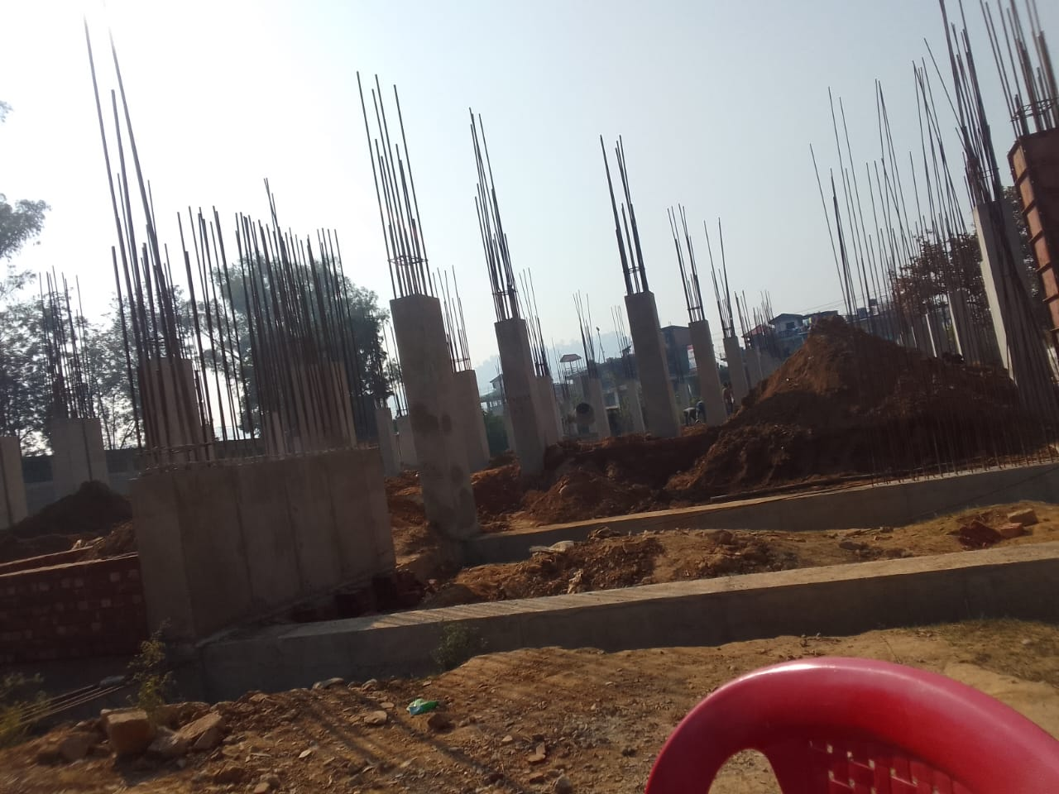

Detailing of beam reinforcement-

25mm main reinforcement with 10 MM shear reinforcement @6"*CI C* spacing. 20mmreinforcement with 8mm shear reinforcement @6" *CI C* spacing.

**TYPES OF BEAM**

1. Joist-When provided in buildings to support roofs, they are calledjoists.

2. Girder- a large beam supporting a number of joists.

3. Spandrels- exterior beams at floor level of building, which carries part

of the floor load and that of the exterior wall are called spandrels.

4. Purling- beam which carry roof load in trusses.

5. Lintels- which support the loads from the masonry over the openings

**COLUMN:-**

Column is a supporting pillar and a structural element which transfers the upcoming load and it’s self-weight to the hard soil through foundation or a column is defined as a vertical compression member which is mainly subjected to axial loads and the effective length of which exceeds three times its lateral dimension. Failure occurs when the stresses due to direct axial loads exceeds the compressive strength of the material available in the cross section. On the other hand, an eccentric load can produce bending and results in uneven distribution of stress

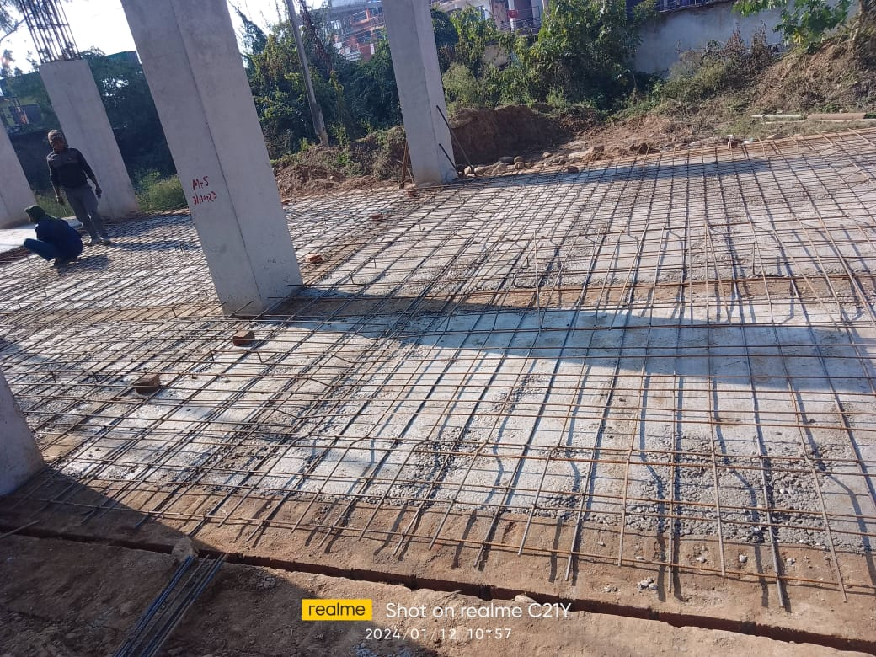.

.

**STEPS AND STAIRS**

A step usually consists of a thread and riser supported by strings. A stair is a

structure consisting of number of steps and is provided to afford the means of

ascent and descent between the floor and landings, which is easiest and quickest

service possible to building. The palace in building where stair is located is

called stair case and the space occupied by it is called a stair way. Different

kinds of stairs are used in buildings such as timber, bricks, stones, steel, plain or

reinforced cement concrete and combination of different materials. Selection of

material to be used for construction depend s upon funds available, availability of

materials and type of buildings. In detention center plain cement concrete stairs

are used with kola stone flooring with straight pattern

**DETAIL OF ROOFING**

Reinforcement details in slabs-

1. Main reinforcement-

I0mm dia. bars of Fe4 I5 Grade of HYSD steel reinforcement @ 6"*CIC*spacing.

2. Secondary reinforcement -

8mm dia. bars of Fe 4 I 5 Grade of HYSD steel reinforcement @ 6"*CIC* spacing

**CONCRETE MIXER**

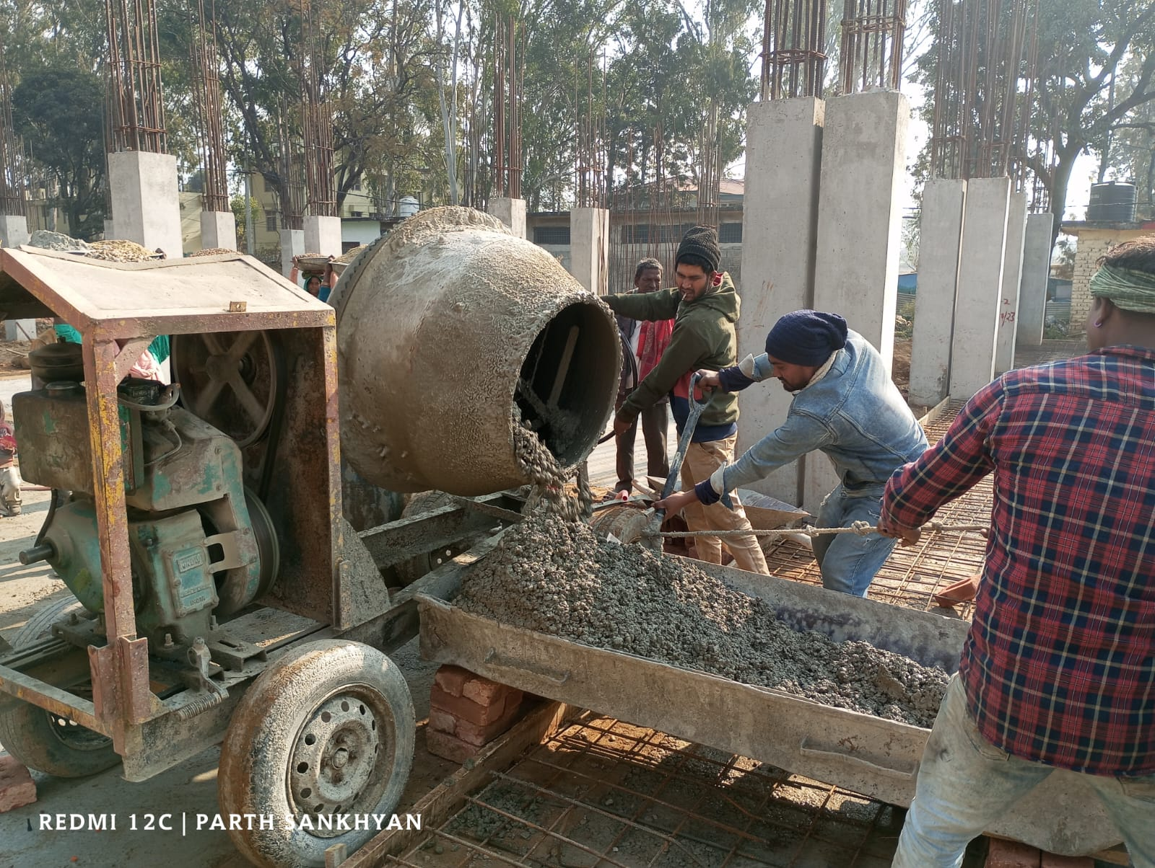

**TRANSPORTATION:**

The process of carrying the concrete mix from the place of its mix ing to final position of deposition

is termed as transportation of concrete. There are many methods of transportation as mentionedbelow-

Transport of concrete by pans

Transport of concrete by wheel barrows

Transport of concrete by tipping Lorries

Transport of concrete by pumps

**CONCLUSION**

We studied different things at training time. These are given as following.

* The general terms of construction are included in this study.
* Different components of buildings.
* Different types of Bonds in brick masonry are also studied in this report.
* Different tastings for materials are studied.
* Reinforcement details of beam, column, and roof are studied practically.
* Nominal covers of beam, slabs, columns etc.

As per my training report l have conclude that, during last 28 days l am familiar with

the construction of brick masonry &mortar preparation and other works under a

Public works department’s project. Brick masonry is provided to transfer the load of

structure to foundation. All though maximum load of building comes on columns and

beams. Various things which couldn't have been possible theoretically were possible

to be learning lot.

THANK YOU